Red Heifer Vision & Interpretation - A CALL TO ACTION!
March 16, 2017
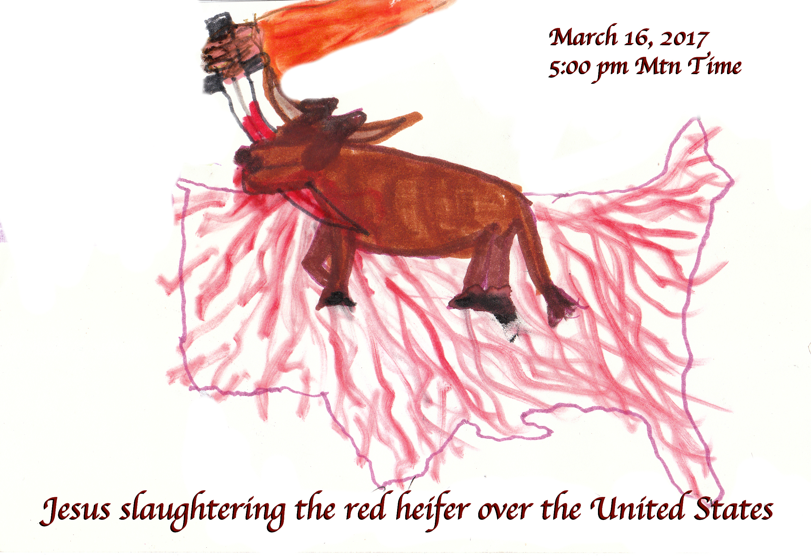
May we all hearken to the Lord’s call to battle, Heartdwellers. This indeed is a new day!

Ezekiel had a powerful vision today right after receiving communion today. He saw, suspended above America, a red Heifer - a young female cow that has never had a calf, that was used for the Temple sacrifice. Priests in Levitical garb came, but Jesus was the one to slaughter the heifer and when He did, the blood ran down from the sky and covered America.

When I came into prayer, I asked the Lord, what is the meaning of the red heifer in this context?

Jesus began, “It’s a symbol for purification by trial. A flushing out of the wickedness that has gripped this nation for far too long. It is more than financial, it is ideological and moral filth that needs to be expunged from America.”

And here's the note that I got from Wikipedia: The ashes from a ceremonially clean and slaughtered (Kosher) red heifer were combined with pure spring water and sprinkled on those who were unclean and had been in contact with a corpse, or someone else who had been in contact with one who had been in contact with a corpse.

The rotten decaying immorality of our nation….

Well, Wikipedia didn't say that, but I see the parallel there... And it's interesting, you know, we have been in contact with a corpse. Our nation has been dead, morally decayed and dead.

Interesting, just the other day the Lord gave me a rhema from Haggai 2:12-19

‘If a man carries holy meat in the fold of his garment, and touches bread with this fold, or cooked food, wine, oil, or any other food, will it become holy?’” And the priests answered, “No.”

Then Haggai said, “If one who is unclean from a corpse touches any of these, will the latter become unclean?” And the priests answered, “It will become unclean.”

Then Haggai said, “ ‘So is this people. And so is this nation before Me,’ declares the LORD, ‘and so is every work of their hands; and what they offer there is unclean.

‘But now, do consider from this day onward: before one stone was placed on another in the temple of the LORD, from that time when one came to a grain heap of twenty measures, there would be only ten; and when one came to the wine vat to draw fifty measures, there would be only twenty. ‘I smote you and every work of your hands with blasting wind, mildew and hail; yet you did not come back to Me,’ declares the LORD.

‘Do consider from this day onward, from the twenty-fourth day of the ninth month; from the day when the temple of the LORD was founded, consider: ‘Is the seed still in the barn? Even including the vine, the fig tree, the pomegranate and the olive tree, it has not borne fruit. Yet from this day on I will bless you.’”

And after this, Jesus continued, “For far too long people have turned a deaf ear to the complaints of those who are grieved by the corruption of this nation. Now is the time to flush the corruption from the soil of this nation so that she may arise in newness of life. This process is always painful; purification is never easy. Decay and death have been the basis for the majority of this nation’s politicians. Maintaining the status quo, passing over the real moral issues and straining on gnats. The time for that is over. I, myself, will see to it that evil is flushed from this government and its deceptive arm, the media.

"The time for indignation is past; now is the time for action. The church has thickened on her lees, it is time for her to awaken the world and take an active roll in seeing to it that righteousness reigns in this country.

"Your president cannot do this alone. He needs every man and woman on board with his agenda. It is your prayers for the nation, your outcries, your educating those who are ignorant, your active roll in fighting this massive front of evil until it comes crashing down.”

But Lord, I thought it would only be suppressed, not stopped.

Jesus continued, “When I remove My Church, then evil will have its opportunity. But until then, Clare, you all have work to do: to pray, inform and enter into spiritual warfare to see to it that wickedness in high places is brought down into the dust.

"This is the clarion call. (A loud and clear call to war.) This is to be a time of defeat for the darkness, a time of frustration and failure. And until I remove the Church, this is what it will be if you shoulder your cross and walk with Me, declaring righteousness and morality the standard of life for your country and politicians. Now is the time to make your opinion heard. Even in songs and art, in letters to editors, in public speaking forums, internet forums, and the like.

"Don’t run from the fight. Stand up and declare what is right without rancor. Make your voices heard, My people. Declare this previous administration so thick with filth to be ruinous to the moral and ethical survival of this nation. Choose your words and your weapons carefully. Prepare the way with prayer and fasting, then make your voice known. It is the grass roots that are going to turn this country on its ear. It is the ruling elite that were destroying it. But the people rising up have indeed put a blockade in their way and I wish for this to grow bigger and healthier and more outspoken.

"Not by ugly remarks nor fighting, but by exposing the truth. You are on a mission to prepare all for My coming, a mission that must include taking responsibility for your government, not turning a deaf ear.

"If you want to live under oppression, famine and persecution, go ahead and medicate yourself with shopping and movies.

"If you want to insure your freedom and rights to love Me, protect your children from crime, drugs and indecent lifestyles, this is the time and season to act.

"I have indeed brought forth the heifer to sanctify this nation and deliver it from its uncleanness and culture of death. But without the reordering of your lives to stand up and be counted for what is right, it will not endure. You must correspond with this grace, My people. You indeed must make your voice heard and make your life count for righteousness."

Lord, would You please show us how to do that?

"It is this simple," Jesus continued. "When you see or hear error, bring forth the truth and stand behind it. Do not expect results if you are not praying first. Remember, ministry of any kind is like an iceberg. Ninety percent is beneath the water and unseen - that's prayer. Ten percent is visible - that's ministry. Likewise, your mission begins with serious intercession. Then, when I bring you opportunities, you will be prepared."

Lord, I have not and still do not feel the burden for this nation I should. Forgive me.

Jesus continued, "That is true enough. But to your credit, when you catch wind of something I pass on to you, you do show serious concern. And it’s not all about how you feel - it’s your commitment to doing the right thing when it’s inconvenient. Will you go out of your way for a serious discussion with one of your children who doesn’t know her right hand from her left as far as the battles of the powers of evil vs. good in this nation? Will you stand the heat when you are scorned for your perspective? How much are you willing to invest? That will determine your return.

"My people, I am dead serious. Rise up and claim dominion over this land. Rise up or perish with it. This is no time to run after your pleasures and distractions. This has been your behavior of the past and that’s what they are counting on. But now you are informed. And you are not of this world."

“Greater is He that dwells in you than he that is in the world.” I John 4:4

"Stand up and take dominion. You are not alone, the hosts of Heaven are marching with you. I am with you, in you and working through you. Stand. Stand up and take dominion."

Well, as a closing note, I wanted to mention to you that after Ezekiel had this vision, he kept hearing a song by Julie True called “Benjamin's Peace”. And I don't know what that's about exactly, because I couldn't find the lyrics and I didn't understand all the words. But it's a very powerful song, and it seems to be about warfare, spiritual warfare. And this song has been playing in his head all day long, ever since he had the vision.

So, I feel that's a confirmation. If any of you have the lyrics, please post them for me.

